Exploring VoyageAI Model

Embeddings Model (voyage-4-lite)
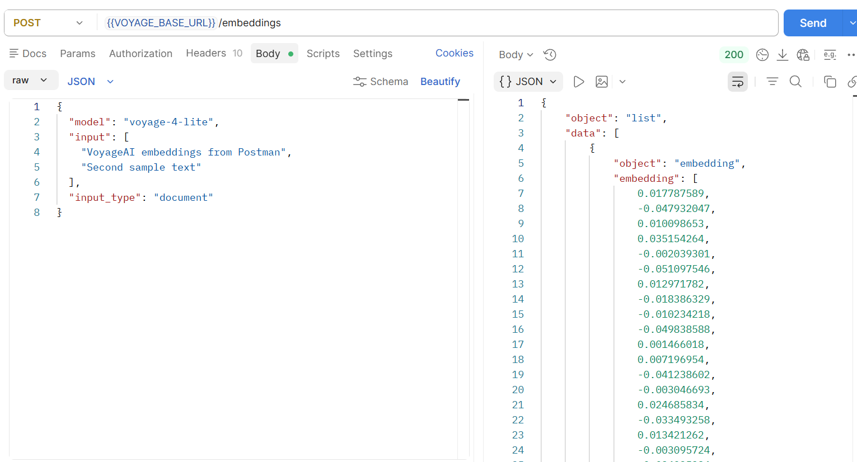
Voyage-4 Model
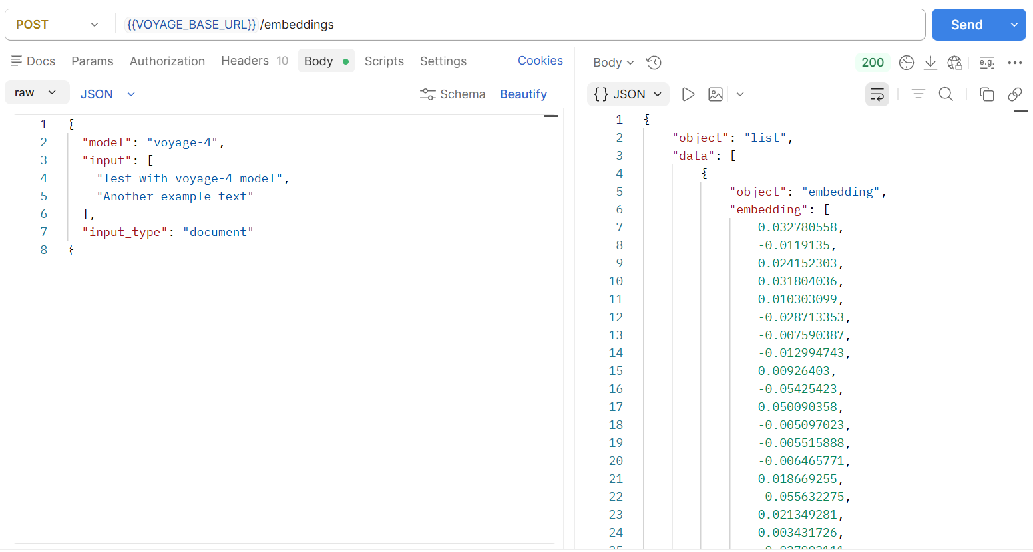

ReRankModel (rerank-2.5-lite)
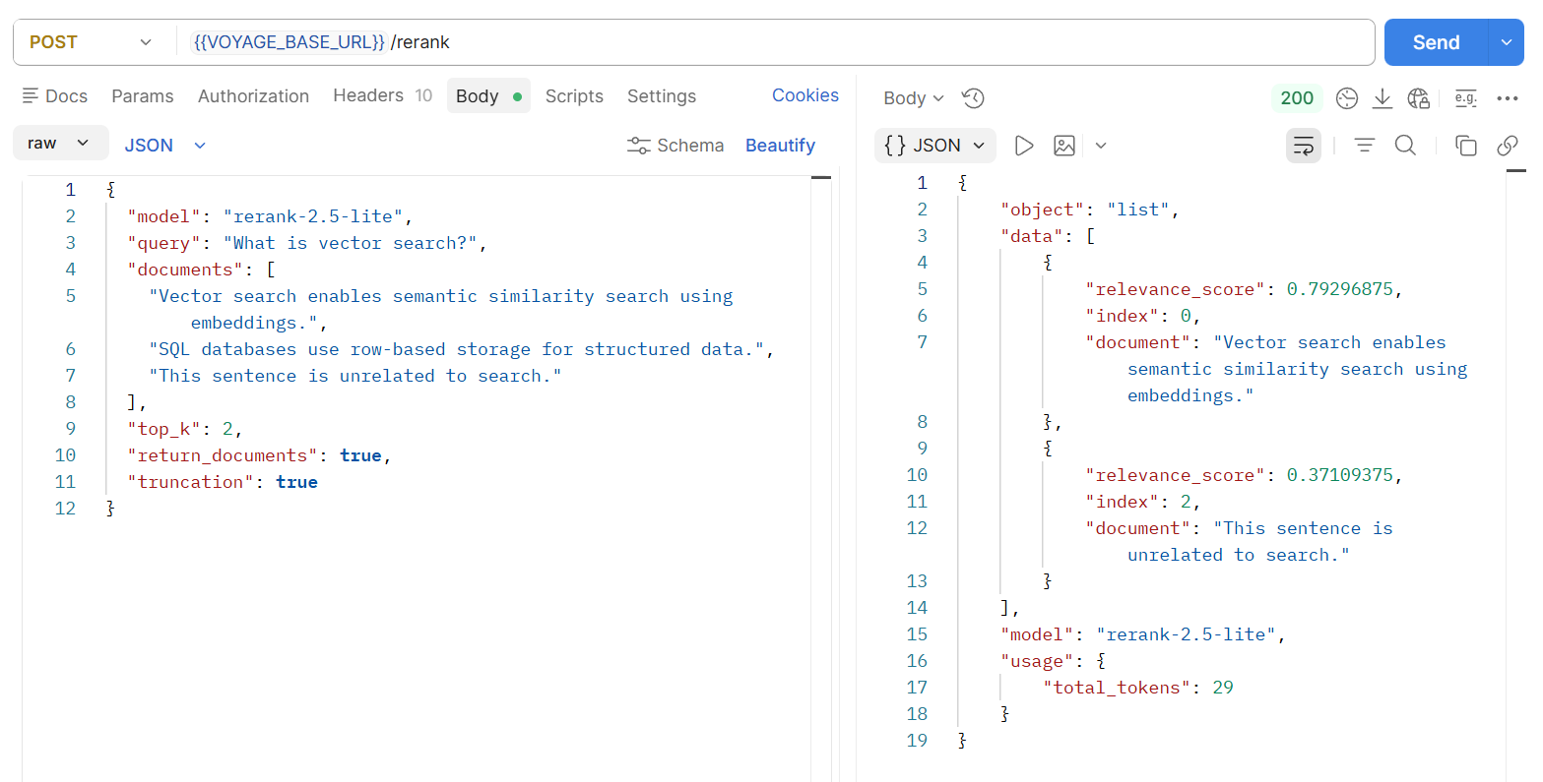

Text Embedding Model (voyage-4-large)
